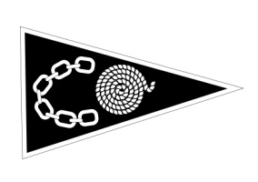
TANKERTON BAY SAILING CLUB
Members Social Calendar 2023

Date | Event | Details | Time
Fri 2nd June | Comedy By the Sea | Local comedians make us laugh at the club with a ploughman supper - £10/ticket | 1830-2230
Sat 15th July | Music on the balcony | Relaxed evening watching the sunset and sharing tales on the balcony | 1800-2200
Sat 19th Aug | Dinghy Regatta BBQ | Great fun dinghy race – followed by a BBQ | 1300-2000
Sat 16th Sept | Quiz Night | Our very own James (Quizmaster) Hills runs a fun quiz | 1830-2230
Sat 21st Oct | AGM and Hot Food | Our AGM followed by food – details TBC | 1800-2200
Sat 18th Nov | Talent Show | Our very own Gordon Fricker will host a talent evening | 1830-2230
Sat 2nd Dec | Laying Up Supper | To be held at the Marine Hotel – details TBC | 1730-2200
Thurs 28th Dec | Mulled Wine & Mince Pies | A relaxed gathering between Christmas & New Year to catch up with old friends | 1500-1900
Fridays – May 26th, June 23rd, July 21st & August 25th are social evenings with the bar open

Further details to be issued closer to each event. Watch out for notices, posters, emails and website. Contact Jane or a committee member if you would like to volunteer to help

